**Operators**

**Operators**: Operators are special symbols or keywords that perform specific operations on one or more operands (values or variables).

**Types of Operators:**

* Arithmetic Operators
* Comparison Operators
* Logical Operators
* Assignment Operators
* Bitwise Operators
* Identity Operators

**1.Arithmetic Operators:** Used to perform mathematical operations.

* Addition: +
* Subtraction: -
* Multiplication: *
* Division: /
* Modulus: %
* Floor Division: //
* Exponentiation: **

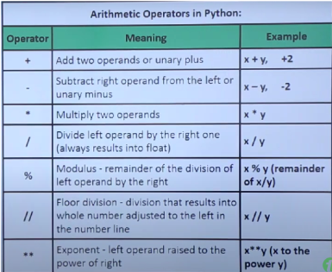

**2.Comparison Operators:** Used to compare values

* Greater than: >
* Less than: <
* Equal to: ==
* Not equal to: !=
* Greater than or equal to: >=
* Less or equal to: <=

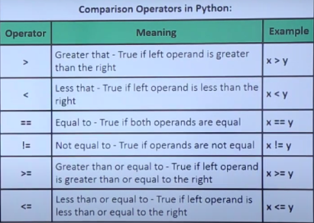

**3.Logical Operators:** Used to combine conditional statements.

* AND: and
* OR: or
* NOT: not

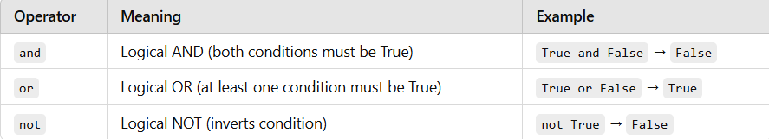

**4.Assignment Operators:** Used to assign values to variables.

* Assign: =
* Add and assign: +=
* Subtract and assign: -=
* Multiply and assign: *=
* Divide and assign: /=
* Modulus and assign: %=

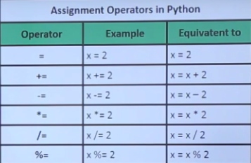

**5.Bitwise Operators:** Used to perform on binary numbers.

* AND: &
* OR: |
* XOR: ^
* Complement: ~
* Left Shift: <<
* Right Shift: >>

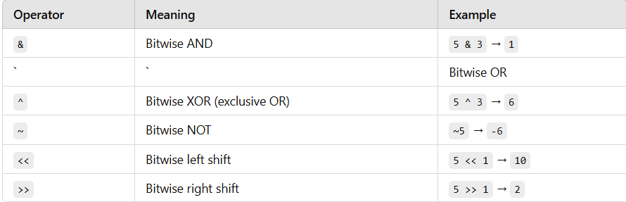

**6.Identity Operators:** Used to compare the memory locations of two objects.

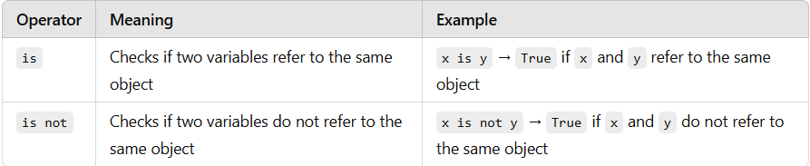

**Membership Operator:** Used to test if a sequence is presented in an object.

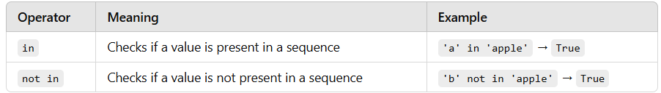

**Task 1: Arithmetic Operators**

1. Create two variables a and b with numeric values.

2. Calculate the sum, difference, product, and quotient of a and b.

3. Print the results.

a=10  
b=20  
print ("Sum is:")  
print (a+b)  
print ("Difference is:")  
print(a-b)  
print ("Product is:")  
print(a*b)  
print ("Quotient")  
print(a/b)

Output:  
Sum is:

30

Difference is:

-10

Product is:

200

Quotient

0.5

**Task 2: Comparison Operators**

1. Compare the values of a and b using the following comparison operators: <, >, <=, >=, == and !=

2. Print the results of each comparison.

a=10  
b=20  
print(a<b)  
print(a>b)  
print(a<=b)  
print(a>=b)  
print(a==b)  
print(a!=b)

Output:

True

False

True

False

False

True

**Task 3: Logical Operators**

1. Create two boolean variables, x and y.

2. Use logical operators (and, or, not) to perform various logical operations on x and y.

3. Print the results.

x="Pass"  
y="Fail"  
print(x and y)  
print(x or y)  
print(not x)  
print(not y)

Output:

Fail

Pass

False

False

**Task 4: Assignment Operators**

1. Create a variable total and initialize it to 10.

2. Use assignment operators (+=, -=, *=, /=) to update the value of total.

3. Print the final value of total.

total=10  
total+=1  
total-=2  
total*=2  
total/=5  
print(total)

Output:

3.6

**Task 5: Bitwise Operators (Optional)**

1. If you are comfortable with bitwise operators, perform some bitwise operations on integer

values and print the results. If not, you can skip this task.

a=8  
b=2  
  
print(a&b)   
print(a|b)   
print(a^b)  
print(~a)  
print(a<<b)  
print (a >> b)

Output:

0

10

10

-9

32

2

**Task 6: Identity and Membership Operators**

1. Create a list my_list containing a few elements.

2. Use identity operators (is and is not) to check if two variables are the same object.

3. Use membership operators (in and not in) to check if an element is present in my_list.

4. Print the results.

**Is and is not**

my_list = [4,1,’laxmi’, 2.3, -20]  
b = my_list  
print(my_list is b)   
print(my_list is not b)

**“in” and “not in”**

print(“laxmi” in my_list)   
print(2.3 not in my_list)

Output:

True

False

True

False